**Task 1** **Database Design:**

1. **Create the database named "HMBank**"

CREATE Database HMBank;

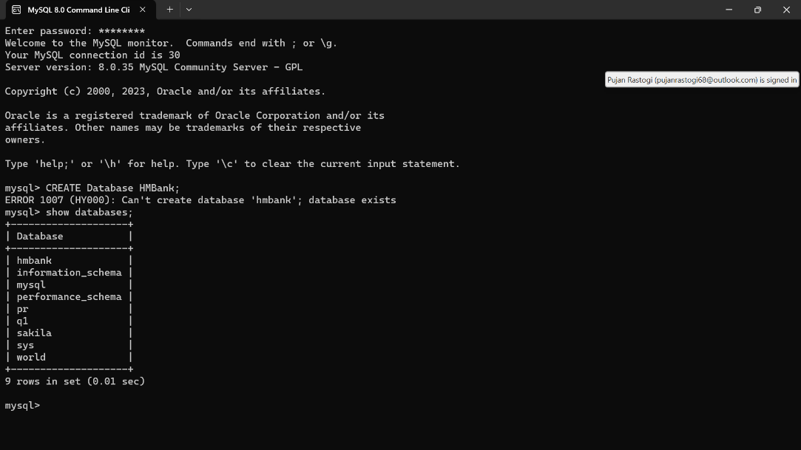

1. **Define the schema for the Customers, Accounts, and Transactions tables based on the provided schema.**

Schema for Customer:

CREATE table Customers(

customer_id INT PRIMARY KEY,

first_name VARCHAR(100),

last_name VARCHAR(100),

DOB DATE,

email VARCHAR(100),

phone_number VARCHAR(100),

address VARCHAR(100)

);

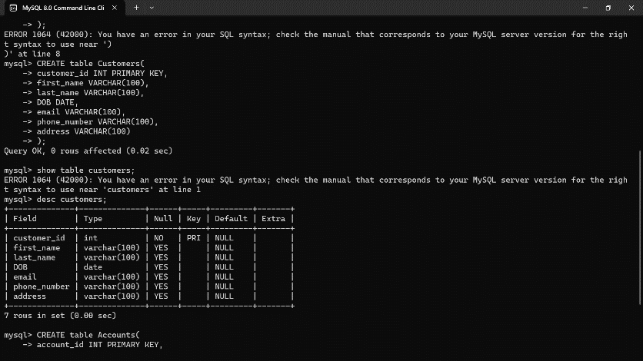

Schema for Accounts:

CREATE table Accounts(

account_id INT PRIMARY KEY,

customer_id INT,

account_type ENUM(‘savings’, ‘current’, ‘zero balance’),

balance DECIMAL (10,2),

FOREIGN KEY(customer_id) REFERENCES Customers(customer_id)

);

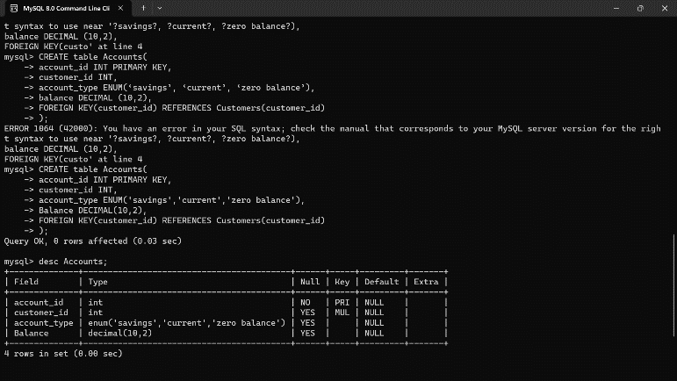

Schema for Transactions:

CREATE table Transactions(

transaction_id INT PRIMARY KEY,

account_id INT,

transaction_type ENUM(‘deposit’, ‘withdrawal’, ‘transfer’),

amount DECIMAL(10,2),

transaction_date DATE,

FOREIGN KEY(account_id) REFERENCES Accounts(account_id)

);

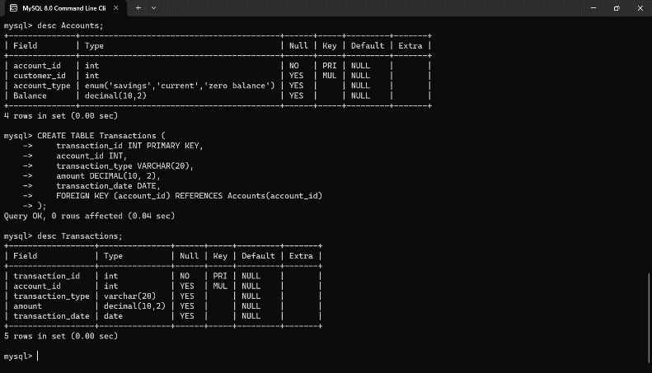

**ER DIAGRAM**

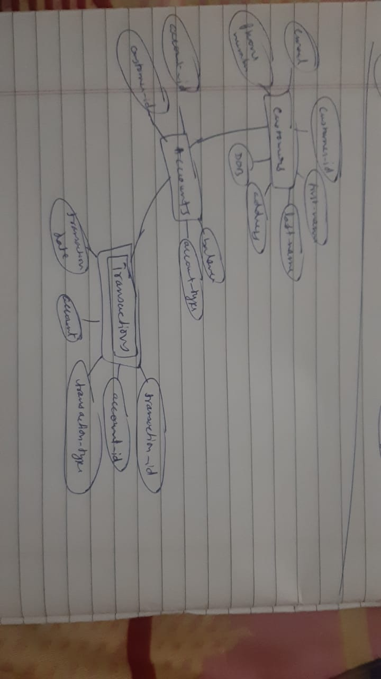

1. **Create appropriate Primary Key and Foreign Key constraints for referential integrity.**

For customer table:

Primary Key constraint for Customers table:

ALTER TABLE Customers

ADD CONSTRAINT P_Customers PRIMARY KEY (customer_id);

Unique constraint for email in Customers table:

ALTER TABLE Customers

ADD CONSTRAINT U_Email UNIQUE (email);

For accounts table:

Primary Key constraint for Accounts table:

ALTER TABLE Accounts

ADD CONSTRAINT PK_Accounts PRIMARY KEY (account_id);

Foreign Key constraint referencing Customers table:

ALTER TABLE Accounts

ADD CONSTRAINT FK_Accounts_Customers FOREIGN KEY (customer_id) REFERENCES Customers(customer_id);

For transactions table:

Primary Key constraint for Transactions table:

ALTER TABLE Transactions

ADD CONSTRAINT PK_Transactions PRIMARY KEY (transaction_id);

Foreign Key constraint referencing Accounts table:

ALTER TABLE Transactions

ADD CONSTRAINT FK_Transactions_Accounts FOREIGN KEY (account_id) REFERENCES Accounts(account_id);

**TASK 2: Select, Where, Between, AND, LIKE:**

1 **Insert at least 10 sample records into each of the following tables. • Customers • Accounts • Transactions**

For Customer table:

INSERT INTO Customers (customer_id, first_name, last_name, DOB, email, phone_number, address)

VALUES

(1, 'Pujan', 'Rastogi', '2002-08-23', 'pujan1@gmail.com', '1234567890', '123 A Street'),

(2, 'Abhi', 'Ag', '2000-09-20', 'abhi@gmail.com', '9876543210', '456 B School'),

(3, 'Abhishek', 'Chaursaiya', '1999-12-10', 'abhich1@gmail.com', '9812347650', '789 C Pass'),

(4, 'Raghav', 'Aggarwal', '1993-01-11', 'raghav@gmail.com', '1237890456', '901 D Road'),

(5, 'Ishan', 'Sharma', '1995-07-17', 'ishan@gmail.com', '2345678901', '232 E Park'),

(6, 'Pranav', 'Dwivedi', '1999-11-03', 'pranav@gmail.com', '3456789012', '365 F Ground'),

(7, 'Alok', 'Yadav', '2003-10-10', 'ALOK@gmail.com', '4567890123', '567 G Hill'),

(8, 'Piyush', 'Upadhyay', '2001-06-27', 'Piyush@gmail.com', '5678901234', '666 H Avenue'),

(9, 'Harsh', 'Singh', '2000-03-07', 'Harsh@gmail.com', '6789012345', '889 I Building'),

(10, 'Rishabh', 'Srivastava', '1998-05-05', 'rishabh@gmail.com', '7890123456', '023 J Shop');

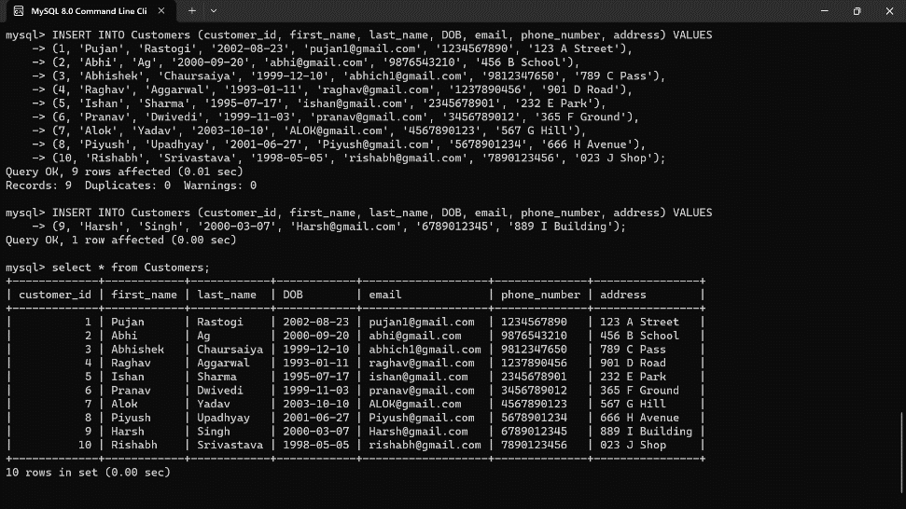

For Accounts table:

INSERT INTO Accounts (account_id, account_type, balance, customer_id)

VALUES

(101, 'savings', 50000.00, 1),

(102, 'current', 25000.00, 2),

(103, 'zero balance', 0.00, 3),

(104, ‘savings’, 20000.00,4),

(105, 'current', 75000.00, 5),

(106, 'zero balance', 0.00, 6),

(107, 'savings', 42500.00, 7),

(108, 'current', 33000.00, 8),

(109, 'zero balance', 0.00, 9),

(110, 'savings', 82000.00, 10);

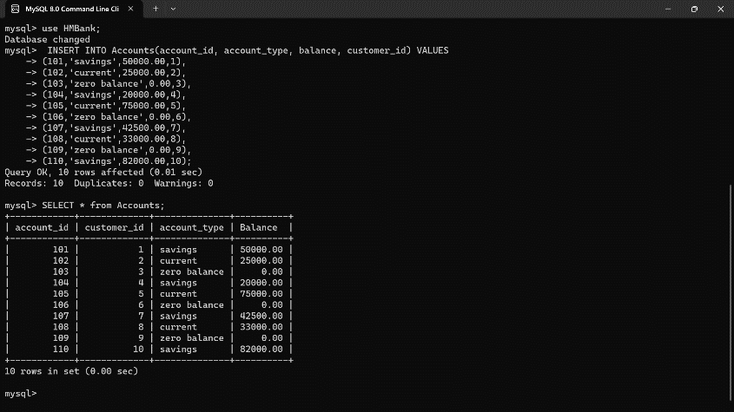

For Transaction table:

INSERT INTO Transactions (transaction_id, transaction_type, amount, transaction_date, account_id)

VALUES

(1001, 'deposit', 1000.00, '2023-01-10', 101),

(1002, 'withdrawal', 500.00, '2023-02-05', 102),

(1003, 'deposit', 3000.00, '2023-03-15', 103),

(1004, 'withdrawal', 6000.00, '2023-04-25', 104),

(1005, 'deposit', 7000.00, '2023-05-20', 105),

(1006, 'deposit', 7000.00, '2023-06-19', 106),

(1007, 'deposit', 9000.00, '2023-07-11', 107),

(1008, 'withdrawal', 10000.00, '2023-08-13', 108),

(1009, 'deposit', 5500.00, '2023-09-27', 109),

(1010, 'withdrawal', 1000.00, '2023-10-06', 110);

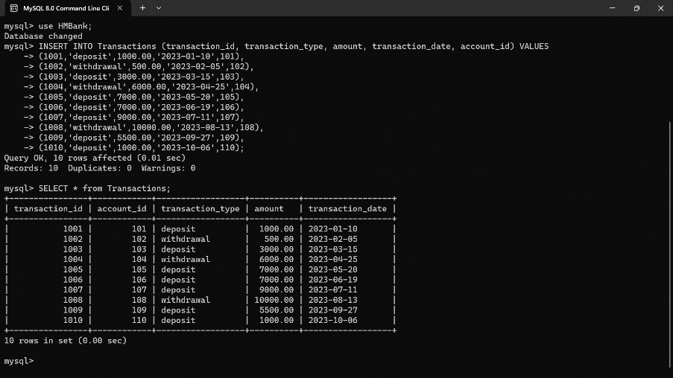

* 1. **Write a SQL query to retrieve the name, account type and email of all customers**

SELECT c.first_name, c.last_name, a.account_type, c.email

FROM Customers c

JOIN Accounts a ON c.customer_id = a.customer_id;

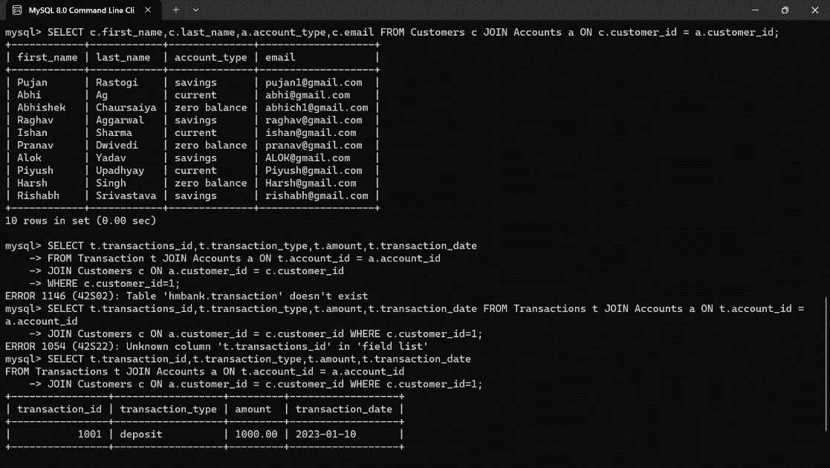

**2.2** **Write a SQL query to list all transaction corresponding customer.**

SELECT t.transaction_id, t.transaction_type, t.amount, t.transaction_date

FROM Transactions t

JOIN Accounts a ON t.account_id = a.account_id

JOIN Customers c ON a.customer_id = c.customer_id

WHERE c.customer_id = 1;

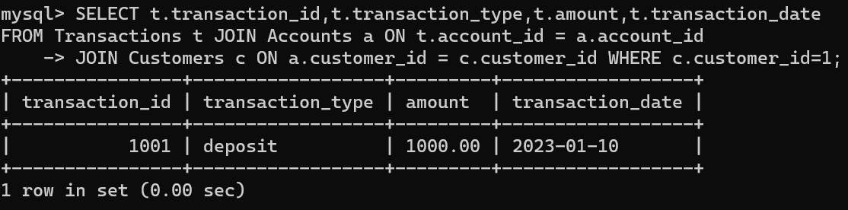

**2.3** **Write a SQL query to increase the balance of a specific account by a certain amount.**

UPDATE Accounts

SET balance = balance + 1000

WHERE account_id = 103;

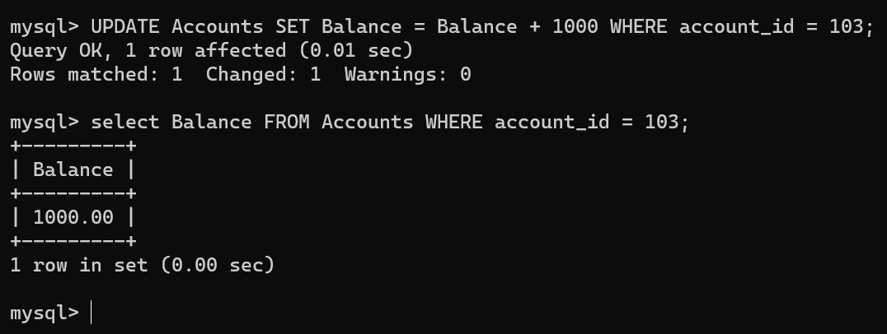

**2.4 Write a SQL query to Combine first and last names of customers as a full_name.**

SELECT CONCAT(first_name, ' ', last_name) AS full_name

FROM Customers;

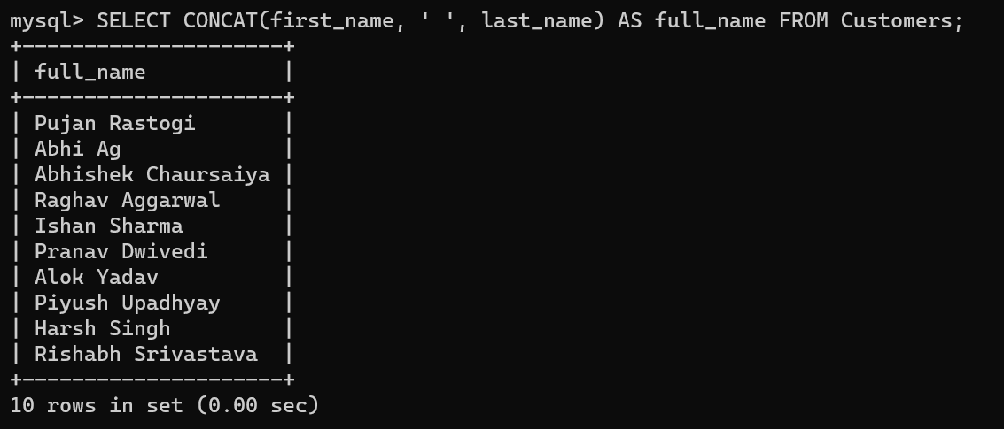

**2.5 Write a SQL query to remove accounts with a balance of zero where the account type is savings.**

DELETE FROM Accounts

WHERE balance = 0 AND account_type = 'savings';

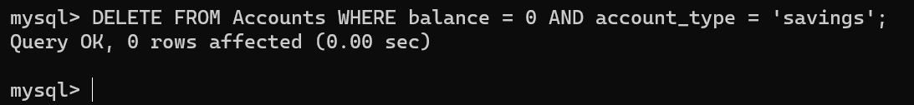

**2.6 Write a SQL query to Find customers living in a specific city.**

SELECT * FROM Customers

WHERE address LIKE ‘023 J Shop’;

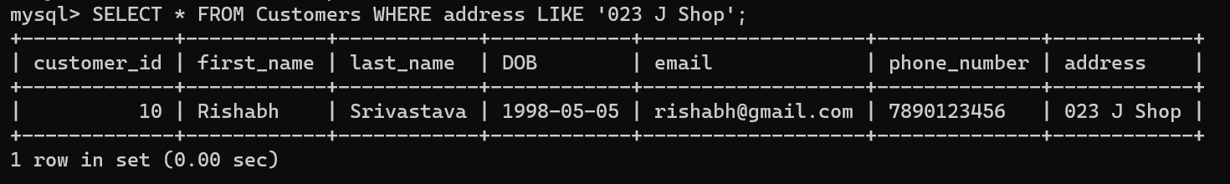

**2.7 Write a SQL query to Get the account balance for a specific account.**

SELECT Balance

FROM Accounts

WHERE account_id = 105;

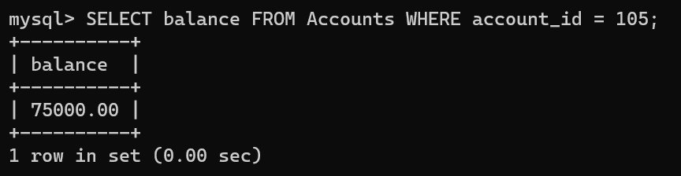

**2.8 Write a SQL query to List all current accounts with a balance greater than $1,000.**

SELECT *

FROM Accounts

WHERE account_type = 'current' AND balance > 1000.00;

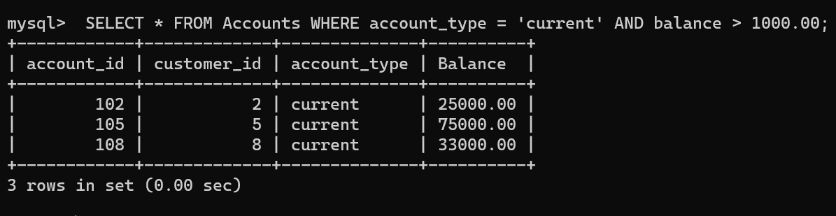

**2.9 Write a SQL query to Retrieve all transactions for a specific account.**

SELECT *

FROM Transactions

WHERE account_id = 107;

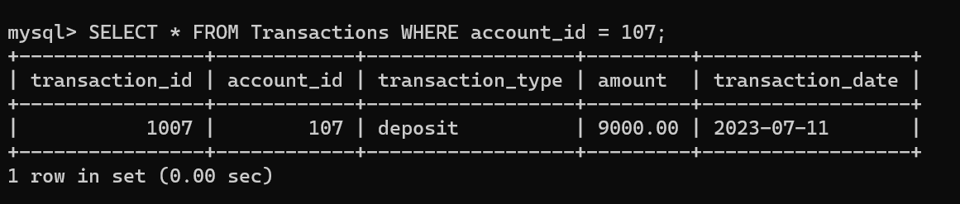

**2.10 Write a SQL query to Calculate the interest accrued on savings accounts based on a given interest rate.**

SELECT account_id, balance * 1.5 / 100 AS interest_accrued

FROM Accounts

WHERE account_type = 'savings';

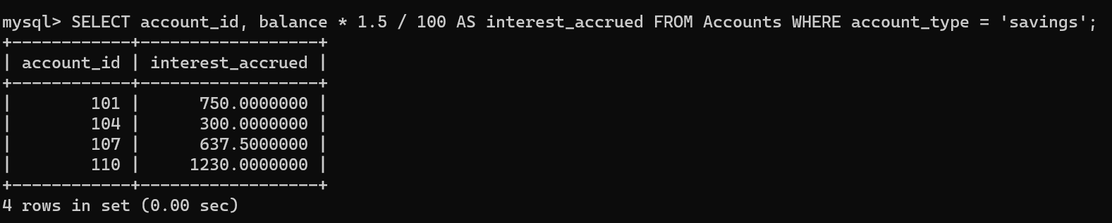

**2.11 . Write a SQL query to Identify accounts where the balance is less than a specified overdraft limit.**

SELECT *

FROM Accounts

WHERE balance < 50000;

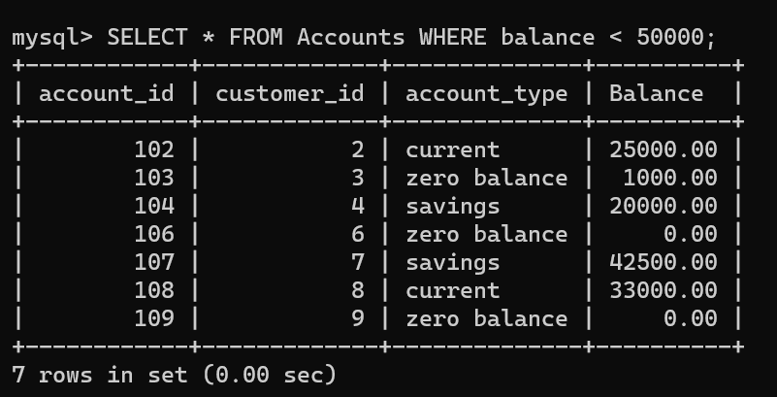

**2.12 Write a SQL query to Find customers not living in a specific city.**

SELECT *

FROM Customers

WHERE address NOT LIKE 666 H Avenue;

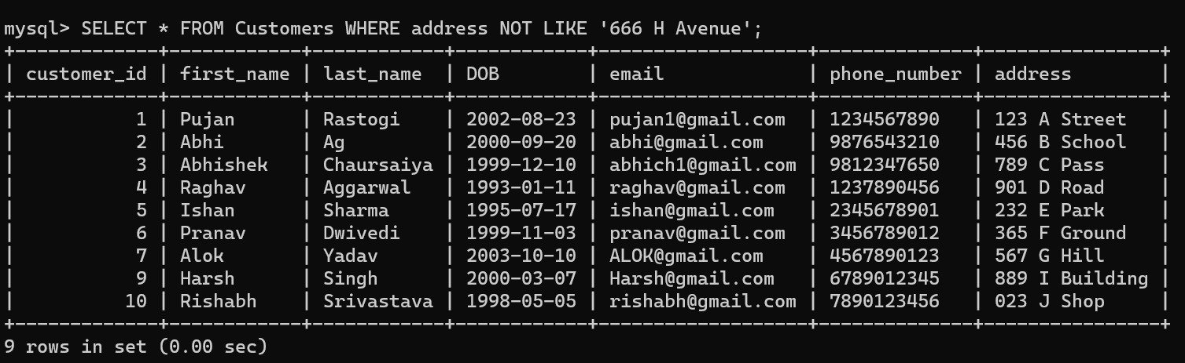

**TASK 3:** **Aggregate functions, Having, Order By, GroupBy and Joins:**

**3.1 Write a SQL query to Find the average account balance for all customers.**

SELECT AVG(balance) AS average_balance

FROM Accounts;

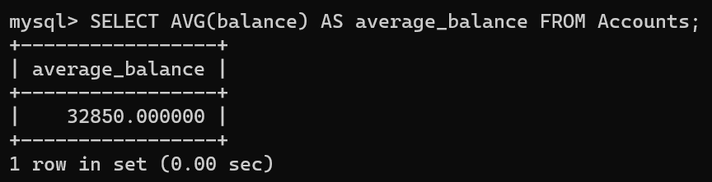

**3.2 Write a SQL query to Retrieve the top 10 highest account balances.**

SELECT * FROM Accounts

ORDER BY balance DESC

LIMIT 10;

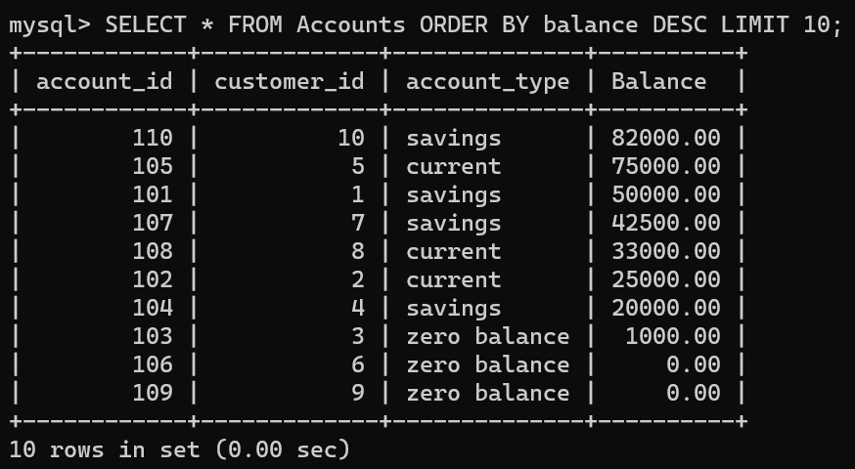

**3.3 Write a SQL query to Calculate Total Deposits for All Customers in specific date.**

SELECT SUM(amount) AS total_deposits

FROM Transactions

WHERE transaction_type = 'deposit' AND DATE(transaction_date) = 2023-03-15;

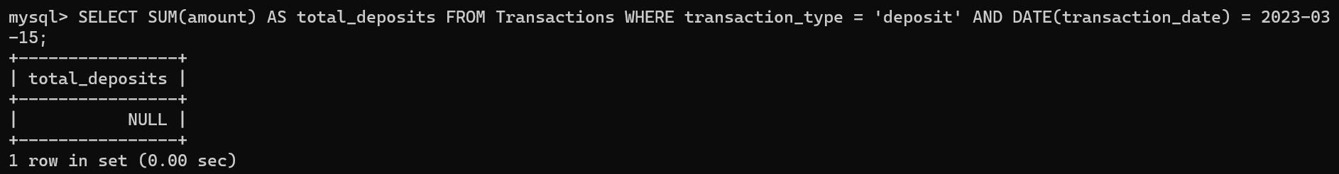

**3.4 Write a SQL query to Find the Oldest and Newest Customers.**

SELECT *

FROM Customers

ORDER BY DOB ASC /* or DESC */

LIMIT 1; /*For the oldest*/

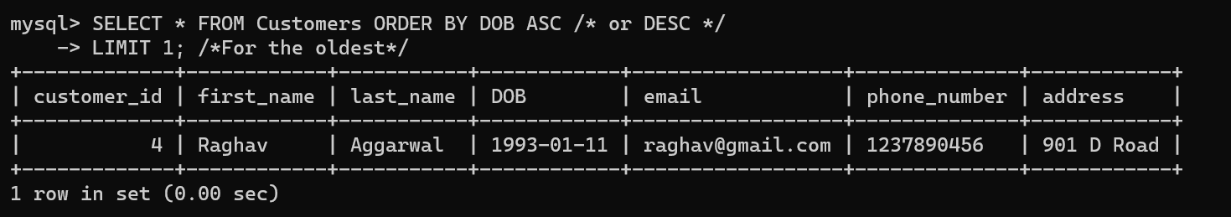

**3.5 Write a SQL query to Retrieve transaction details along with the account type.**

SELECT t.*, a.account_type

FROM Transactions t

JOIN Accounts a ON t.account_id = a.account_id;

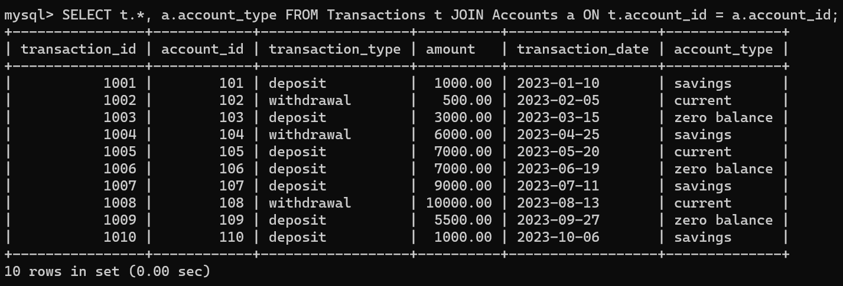

**3.6 Write a SQL query to Get a list of customers along with their account details.**

SELECT c.*, a.*

FROM Customers c

LEFT JOIN Accounts a ON c.customer_id = a.customer_id;

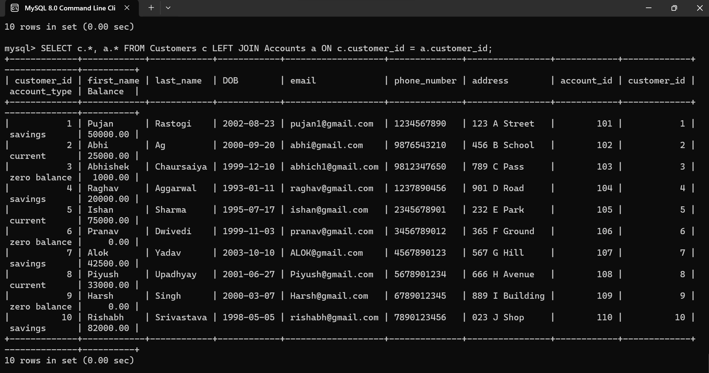

**3.7 Write a SQL query to Retrieve transaction details along with customer information for a specific account.**

SELECT t.*, c.* FROM Transactions t

JOIN Accounts a ON t.account_id = a.account_id

JOIN Customers c ON a.customer_id = c.customer_id

WHERE t.account_id = 104;

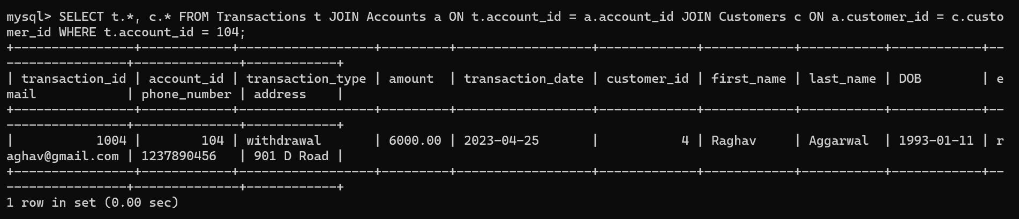

**3.8 Write a SQL query to Identify customers who have more than one account.**

SELECT customer_id

FROM Accounts

GROUP BY customer_id

HAVING COUNT(*) > 1;



**3.9 Write a SQL query to Calculate the difference in transaction amounts between deposits and withdrawals**.

SELECT account_id,

SUM(CASE WHEN transaction_type = 'deposit' THEN amount ELSE 0 END) -

SUM(CASE WHEN transaction_type = 'withdrawal' THEN amount ELSE 0 END) AS difference

FROM Transactions

GROUP BY account_id;

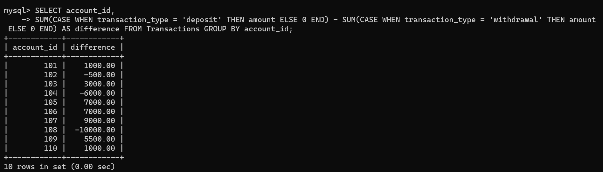

**3.10 Write a SQL query to Calculate the average daily balance for each account over a specified period.**

SELECT transaction_id,

AVG(balance) AS average_daily_balance

FROM Accounts a

JOIN Transactions t ON a.account_id = t.account_id

WHERE transaction_date BETWEEN ‘2023=01-10’ AND ‘2023-12-31’

GROUP BY transaction_id;

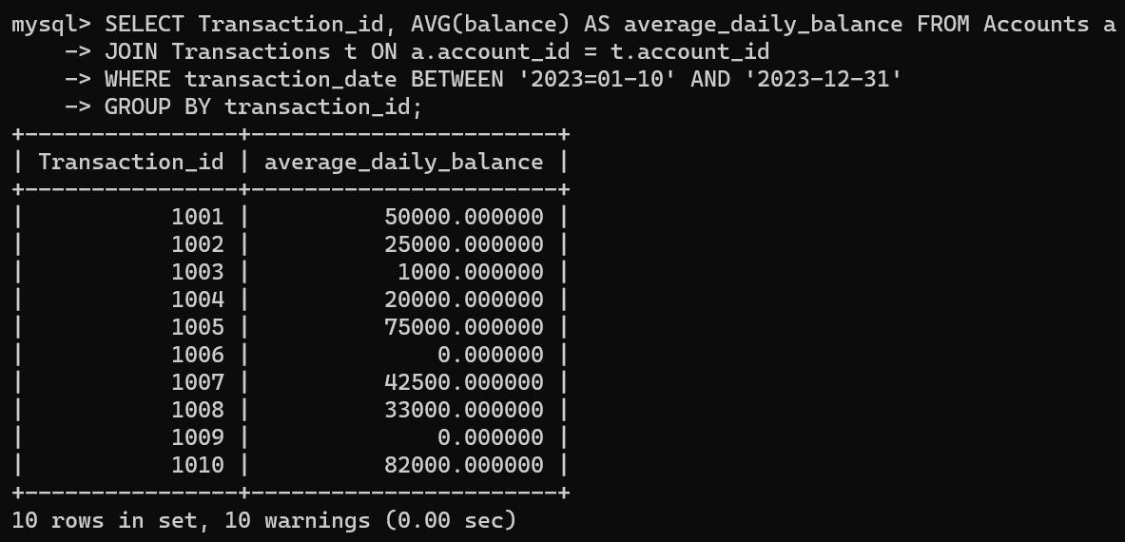

**3.11 Calculate the total balance for each account type.**

SELECT account_type, SUM(balance) AS total_balance

FROM Accounts

GROUP BY account_type;

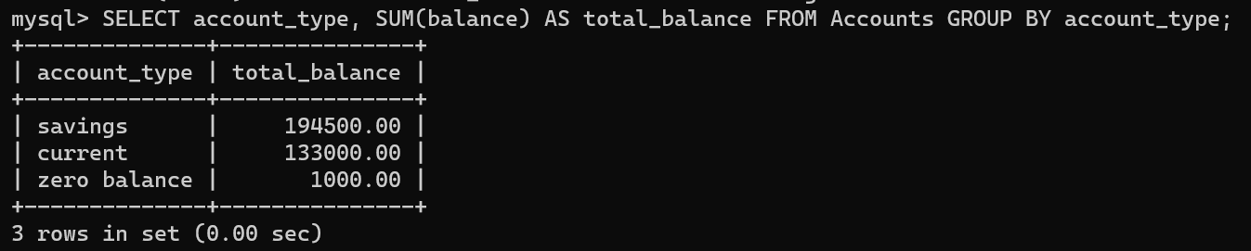

**3.12 Identify accounts with the highest number of transactions order by descending order.**

SELECT account_id, COUNT(*) AS transaction_count

FROM Transactions

GROUP BY account_id

ORDER BY transaction_count DESC;

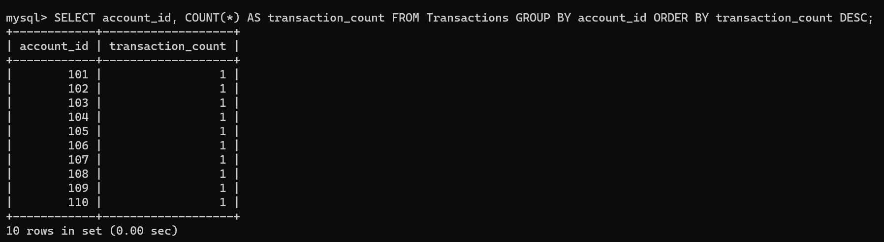

**3.13 List customers with high aggregate account balances, along with their account types.**

SELECT c.customer_id, c.first_name, c.last_name, a.account_type, SUM(a.balance) AS total_balance

FROM Customers c

JOIN Accounts a ON c.customer_id = a.customer_id

GROUP BY c.customer_id, a.account_type

HAVING total_balance > 30000;

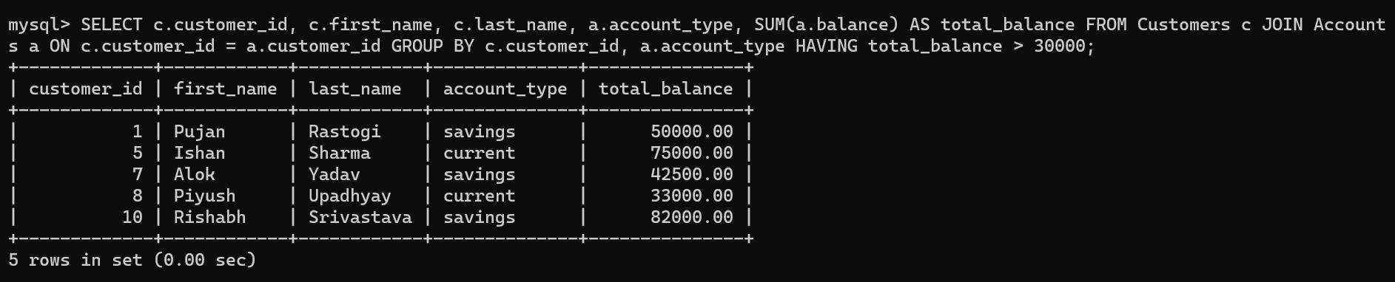

**3.14 Identify and list duplicate transactions based on transaction amount, date, and account.**

SELECT transaction_id, amount, transaction_date, account_id, COUNT(*) AS occurrences

FROM Transactions

GROUP BY transaction_id, amount, transaction_date, account_id

HAVING occurrences > 1;



**TASK 4: Subquery and its type:**

**4.1 Retrieve the customer(s) with the highest account balance.**

SELECT c.* FROM Customers c

JOIN Accounts a ON c.customer_id = a.customer_id

ORDER BY a.balance DESC

LIMIT 1;

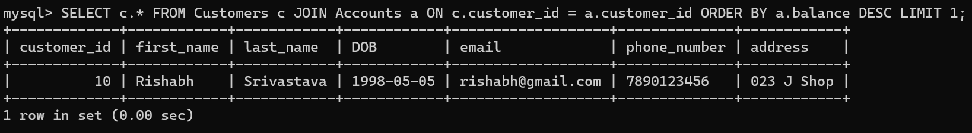

**4.2 Calculate the average account balance for customers who have more than one account.**

SELECT customer_id, AVG(balance) AS avg_balance FROM Accounts

GROUP BY customer_id

HAVING COUNT(*) > 1;



4.3 Retrieve accounts with transactions whose amounts exceed the average transaction amount.

SELECT DISTINCT a.* FROM Accounts a

JOIN Transactions t ON a.account_id = t.account_id

WHERE t.amount > (SELECT AVG(amount) FROM Transactions);

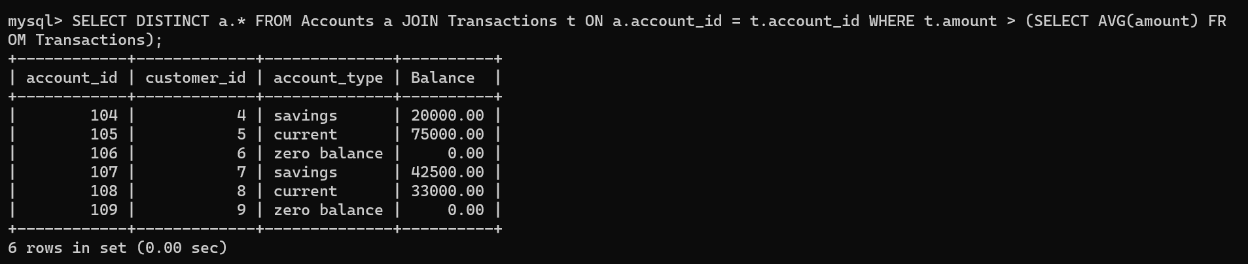

**4.4 Identify customers who have no recorded transactions.**

SELECT c.* FROM Customers c

LEFT JOIN Accounts a ON c.customer_id = a.customer_id

LEFT JOIN Transactions t ON a.account_id = t.account_id

WHERE t.transaction_id IS NULL;

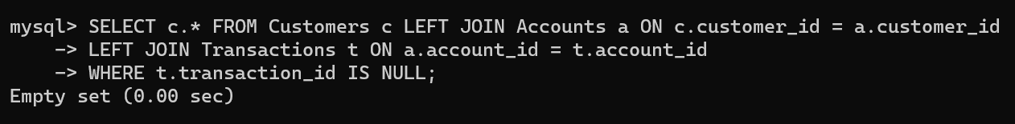

**4.5 Calculate the total balance of accounts with no recorded transactions.**

SELECT SUM(balance) AS total_balance_no_transactions FROM Accounts

WHERE account_id NOT IN (SELECT account_id FROM Transactions);

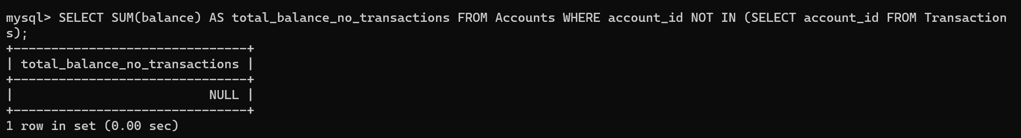

**4.6 Retrieve transactions for accounts with the lowest balance.**

SELECT t.* FROM Transactions t

JOIN Accounts a ON t.account_id = a.account_id

WHERE a.balance = (SELECT MIN(balance) FROM Accounts);

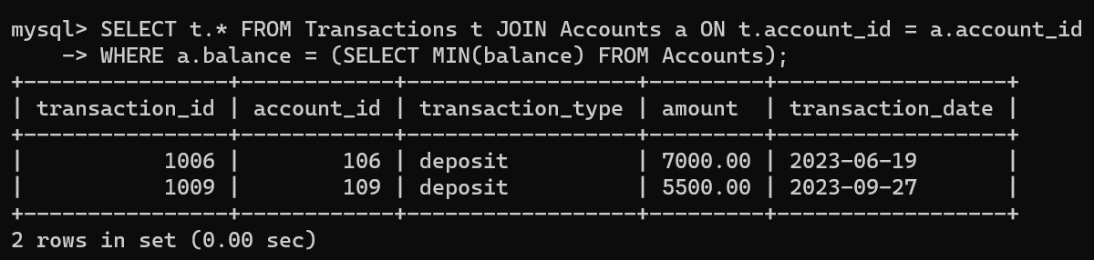

**4.7 Identify customers who have accounts of multiple types.**

SELECT customer_id FROM Accounts

GROUP BY customer_id

HAVING COUNT(DISTINCT account_type) > 1;



**4.8 Calculate the percentage of each account type out of the total number of accounts.**

SELECT account_type, COUNT(*) * 100.0 / (SELECT COUNT(*) FROM Accounts) AS percentage

FROM Accounts

GROUP BY account_type;

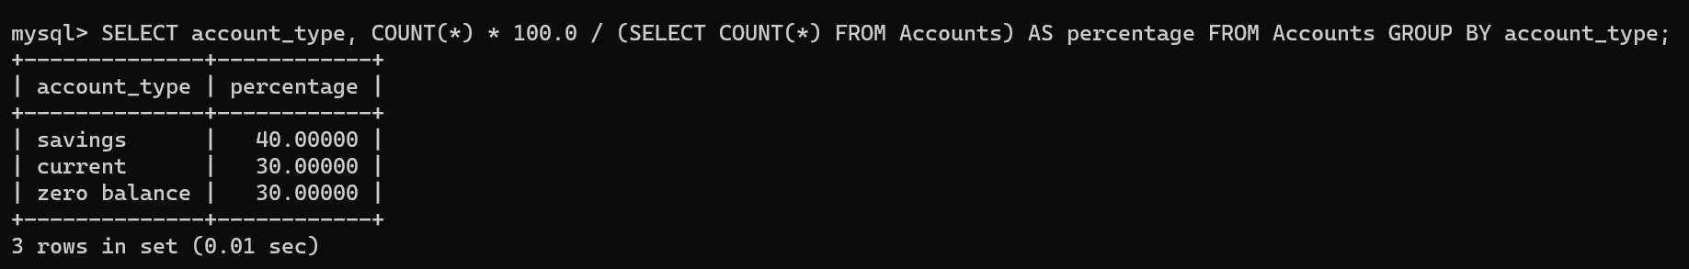

**4.9 Retrieve all transactions for a customer with a given customer_id.**

SELECT t.* FROM Transactions t

JOIN Accounts a ON t.account_id = a.account_id

WHERE a.customer_id = 9;

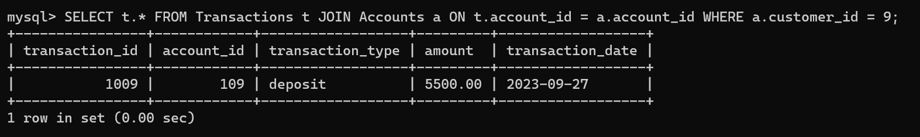

**4.10 Calculate the total balance for each account type, including a subquery within the SELECT clause.**

SELECT account_type, (SELECT SUM(balance) FROM Accounts a WHERE a.account_type = acc.account_type) AS total_balance

FROM (SELECT DISTINCT account_type FROM Accounts) AS acc;

